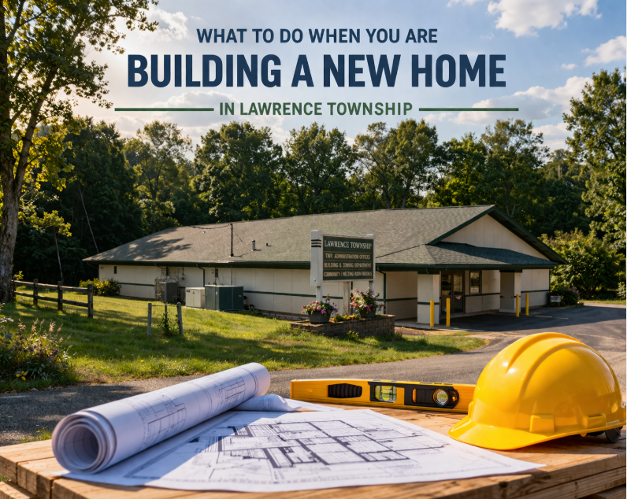

Contact Michigan Code Inspections, LLC to begin the process to obtain a building permit and describe intent of project. Paper Building Permit forms are available at the Lawrence Township Hall during business hours. They can be accepted and scanned to MCI,LLC. If you need additional help you may email questions to housing@lawrence-township.org.
WWW.MCILLC.US

Building permit checklist for new structures:
Completed application including parcel number and property address:
If new address has been assigned a document from Van Buren County assigning the new number is required. New property addresses are assigned by:
Van Buren County – Digital Information
Digital Information - Van Buren County
219 E. Paw Paw St. Suite 201 Paw Paw, MI 49079
269-657-8243

Approval of a new driveway:
Driveway permits are approved by the County Road Commission:
Van Buren County Road Commission | Michigan | Government
Van Buren County Road Commission----325 W James St. PO Box 156 Lawrence, MI 49064
269-674-8011
Approval of new well and septic systems:

Well and septic permits are issued by the Van Buren / Cass District Health Department:
Home - Van Buren / Cass District Health Department
Van Buren / Cass District Health Department----260 South St. Lawrence, MI 49064
269-621-3143
Michigan Uniform Energy Code:

All new homes must meet the current energy codes.
Soil Erosion permit

Soil Erosion permits are required whenever moving more than 1 acre of earth and/or disturbing soils WITHIN 500 feet of lakes, streams, ponds or wetlands. These permits are issued by the Van Buren County Drain Commissioner:
VBC Drain Commissioner----219 E. Paw Paw Street Suite 301 Paw Paw, MI 49079
269-657-8241

Site plan for zoning review and approval:
A comprehensive site plan(Bird’s Eye View Drawing) showing the location of the new construction and the distance from any lot lines and other structures including well and septic systems. Please feel free to include additional sheets when necessary. We forward this information to the Zoning Administrator for zoning review. We need to wait for zoning approval before issuing a permit. Please be sure your site plan contains the details necessary for review. If you have specific zoning questions, please contact the local Zoning Administrator.
Lawrence Township - Christopher Mihelich 269-539-9074 zoning@lawrence-township.org
Permit information for various items FAQ:

Fencing:
Fencing over 7’ in height does require a building permit. Complete the standard building permit and submit. Fencing under 7’ in height does not require a building permit. However, you do need zoning approval. Contact the local zoning official for information:

Lawrence Township - Christopher Mihelich 269-539-9074 zoning@lawrence-township.org

Roofing:
Roofing replacement and repairs do require a building permit. The cost of the permit is dependent on the nature of the project. Please describe the project in detail on the building permit. Examples can include “removal of shingles and complete re-roof”, “replacement or repair of decking”, “replacement or repair of trusses”, etc. No site plan is required for these permits.
Inground/Above ground pools:
Building permits are required. Describe the type and dimensions of the project. A detailed site plan is required, and it must also identify any additional yard improvements such as concrete or decking. Fencing or automatic covers are required for pools unless it is an above ground pool that is 48 inches or higher. Above ground must have removable ladder. We currently charge the pool permit fee plus an additional $300 escrow for the fencing or retractable cover. Once fencing or cover is installed, the $300 is refunded back.
Demolition:
Demo permits are required. This is critical as we pass this information on to the Assessing Department to ensure the items are removed from the tax roll the year following removal.
Agricultural structures:
Permits for agricultural structures are required. An affidavit must be included with the building permit affirming that the structure will be used for agricultural purposes only. There are no fees and no inspections for agricultural permits. However, the permit must be reviewed by zoning to ensure zoning requirements are met. Please submit a building permit detailing the structure to be built and a site plan suitable for zoning review. ASK FOR AFFIDAVIT.
Remodeling:
Permitting for remodeling projects is dependent on the project. Basic repairs or updates do not require a permit. For example: new flooring such as carpeting or tile work, new interior trim, etc. However larger projects that involve exposing studs or floor joist do require a permit. It should be noted that even though a building permit may not be required other permits (electrical, mechanical or plumbing) may be necessary. Please email us with the details of your project and we can help guide you in the right direction. EMAIL: Permits.MCILLC@GMAIL.COM
Lawrence Township Website : WWW.LAWRENCE-TOWNSHIP.ORG

